|  |  |
| --- | --- |
| Name | Yash Shinde |
| NUID | 001493321 |
| Course | DWBI Online |
| Assignment | 10 (Talend Profiling) |

1. Following is the simple statistical analysis performed over data on Talend. In which as we can see, all the types of counts such as Row, Null, Distinct, Unique, Duplicate, and Blank are obtained on a easy click. Unlike while performing the profiling using SSDT where there would be lengthy commands and highly prone to errors with long time to process data, Talend uses certain commands to get quick results.

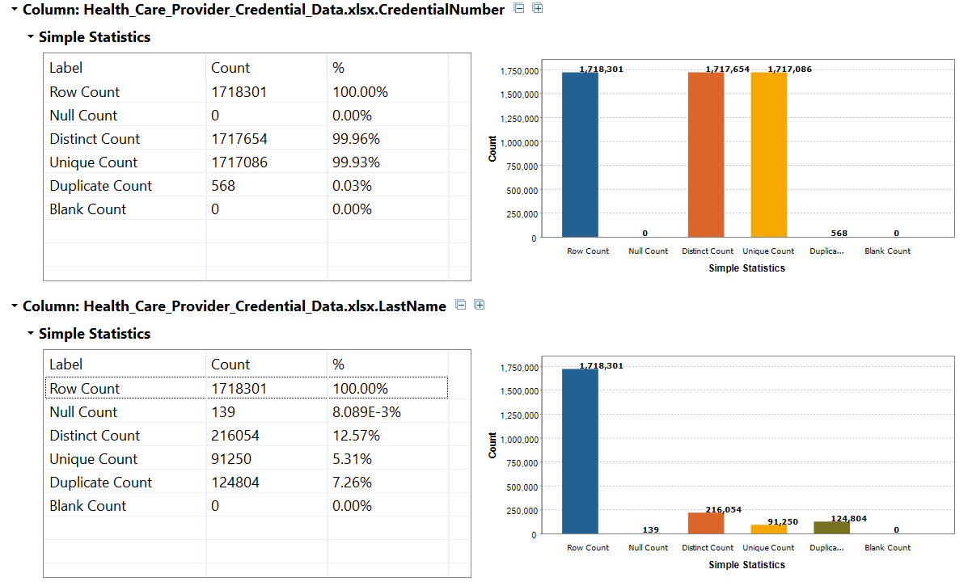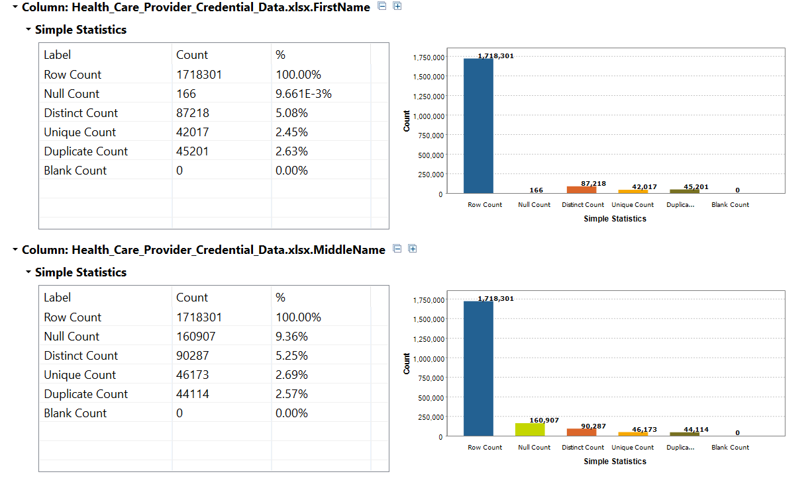

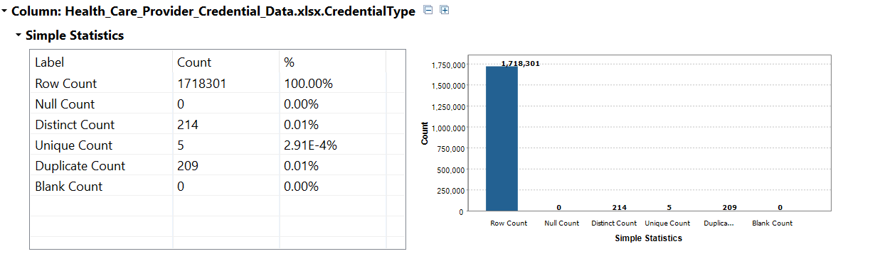

2. In this second analysis, I have made an effort to replicate one of the findings from my HW6 where I concluded there were very less No. of records between year 1860 to 1900 using Tableau. Clearly, in the following analysis, it hasn’t come out very precise. 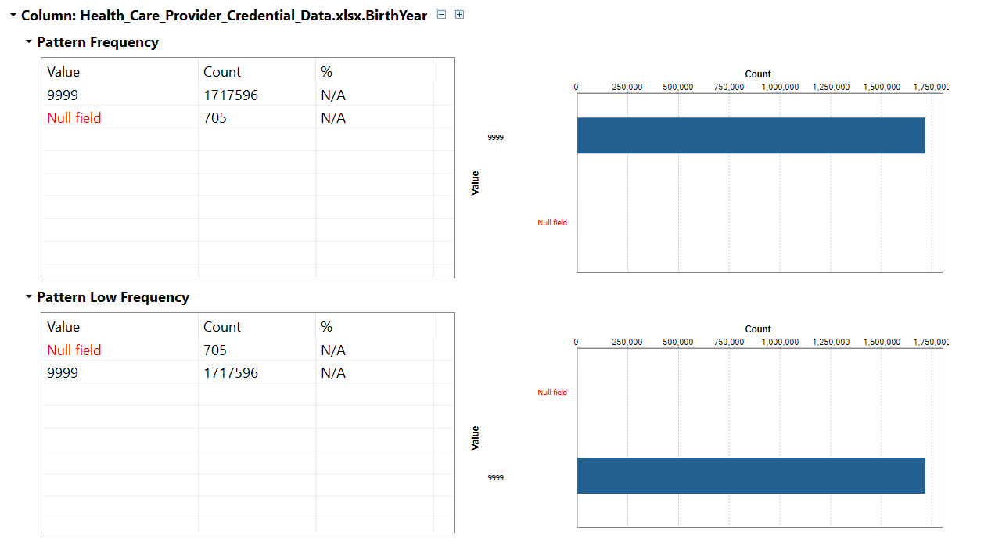

Below is the tableau representation of the same matter.

